Experimental values
- Mean diagnosis age $≈$ 60 years (54, 69) [1]
- Mutation rate $≈{1.02×10}^{-9}$/nucleotide/cell division [2]
- Mean mutation count $≈{10}^{4}$ [3]
- Mean MRCA age $≈$ - 0.3 years (0.1, 1.8) [1]
- Doubling time $≈$ 4 months in early stage, 2.5 months in late stage [4]
- Cell lifespan: $≈$ 10 days (for epithelial cells) [5]
Model assumption
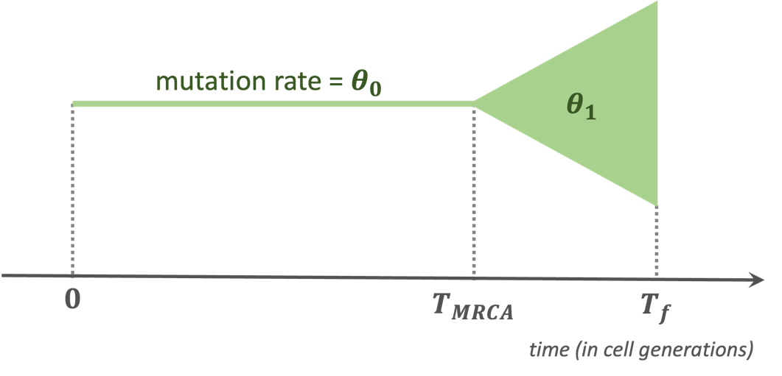
- Final time point $T_{f}$ = 60 year / 10 days = 2190 cell generations
- Tumor age $∼Uniform(1,20)$ years
$⟹$ MRCA time point $T_{MRCA}∼\left[60-Uniform\left(1,20\right)\right]/10$ cell generations
- Tumor size at $T_{f}$ = ${10}^{6}$ cells
- Sample size at $T_{f}$ = ${10}^{4}$ cells
- Mutation rate/cell division = genome length $×$ mutation rate/nucleotide/cell division = $6×{10}^{9}×{1.02×10}^{-9}=6.12$
Tumor mutation rate is likely to be higher than in normal tissues
$⟹$ $θ_{0}=6.12$; $θ_{0}∼Uniform\left(1,20\right)×6.12$
- Tumor purity $∼Uniform\left(0.5,1\right)$
- WGS sampling coverage $∼Uniform\left(30,60\right)$
With these assumptions, mutation count is $≈{10}^{4}$ as observed in Experimental value 3
References
1. Gerstung M, Jolly C, Leshchiner I, Dentro SC, Gonzalez S, Rosebrock D, et al. The evolutionary history of 2,658 cancers. Nature. 2020;578(7793):122-8. Epub 2020/02/07. doi: 10.1038/s41586-019-1907-7. PubMed PMID: 32025013.
2. Kovalchuk I. Genome stability: An evolutionary perspective. Genome Stability2021. p. 1-19.
3. Consortium ITP-CAoWG. Pan-cancer analysis of whole genomes. Nature. 2020;578(7793):82-93. Epub 2020/02/07. doi: 10.1038/s41586-020-1969-6. PubMed PMID: 32025007; PubMed Central PMCID: PMCPMC7025898.
4. Danesh K, Durrett R, Havrilesky LJ, Myers E. A branching process model of ovarian cancer. Journal of Theoretical Biology. 2012;314:10-5. doi: 10.1016/j.jtbi.2012.08.025.
5. Sender R, Milo R. The distribution of cellular turnover in the human body. Nature Medicine. 2021;27(1):45-8. doi: 10.1038/s41591-020-01182-9.

